ComplexWeb Activity

Now go to the console of visual studio and run the commands as below :

1. Go to the ComplexWeb project folder by using **cd** command

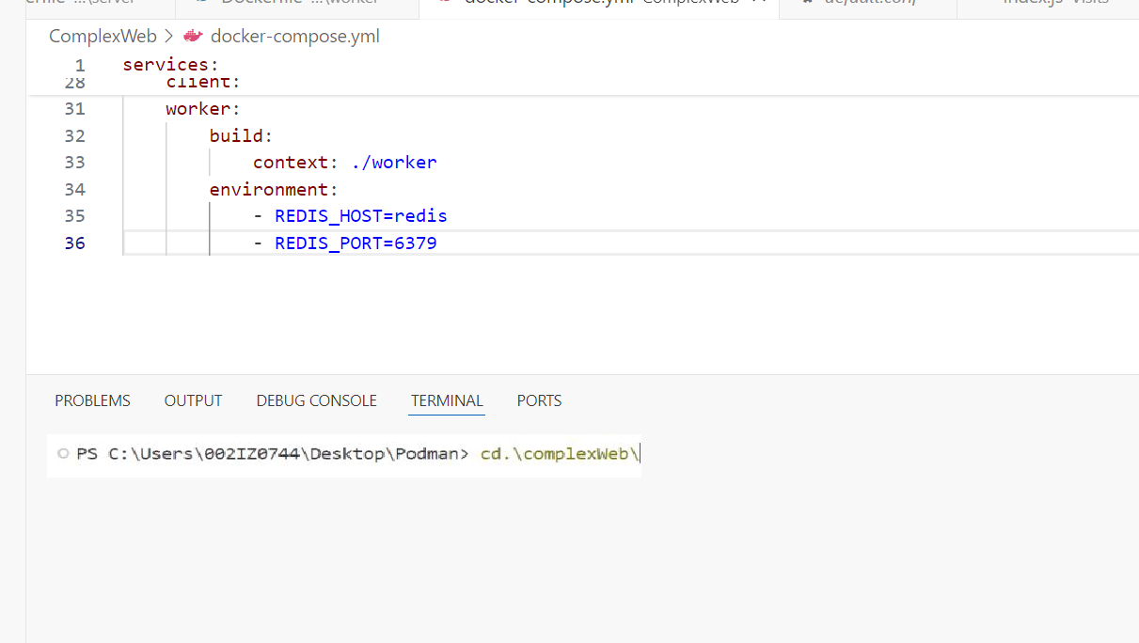

1. Now run this command to build the containers

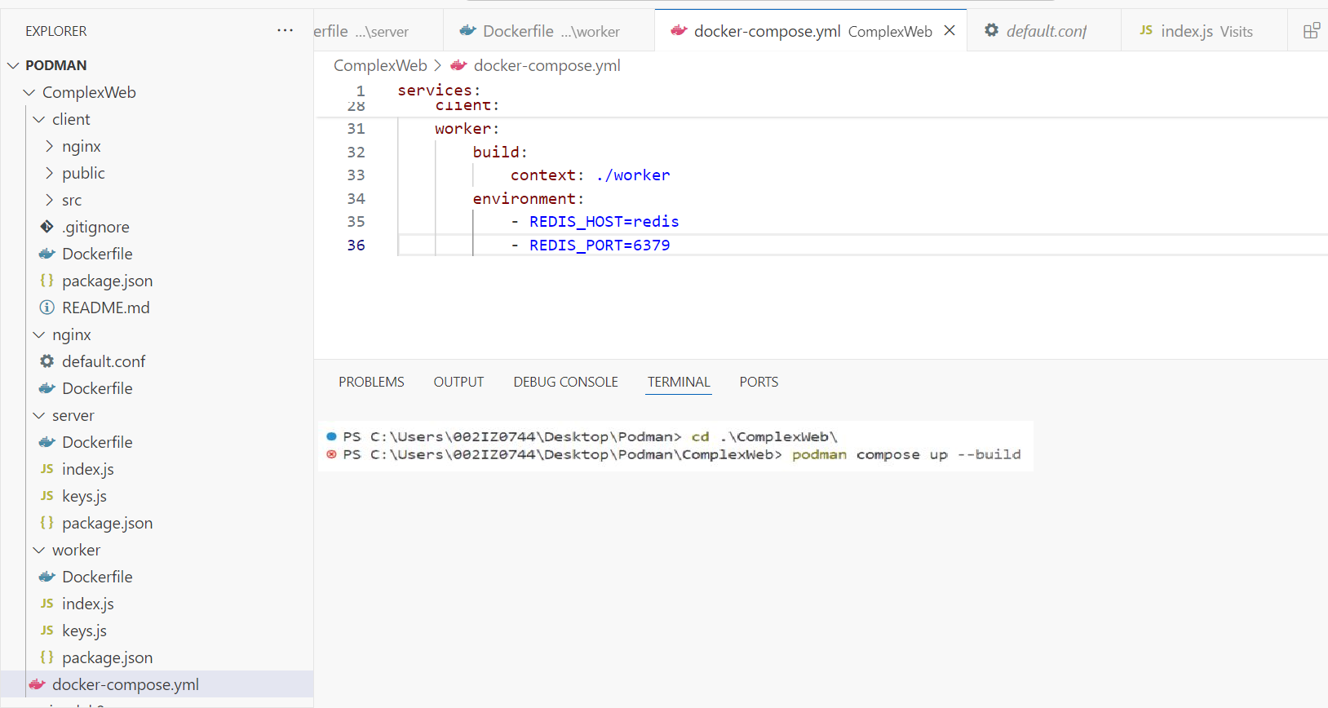

1. Build is composed and our server started running

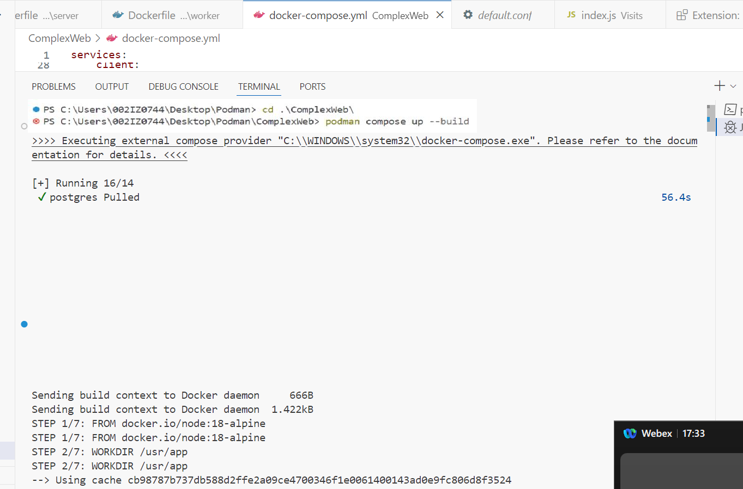

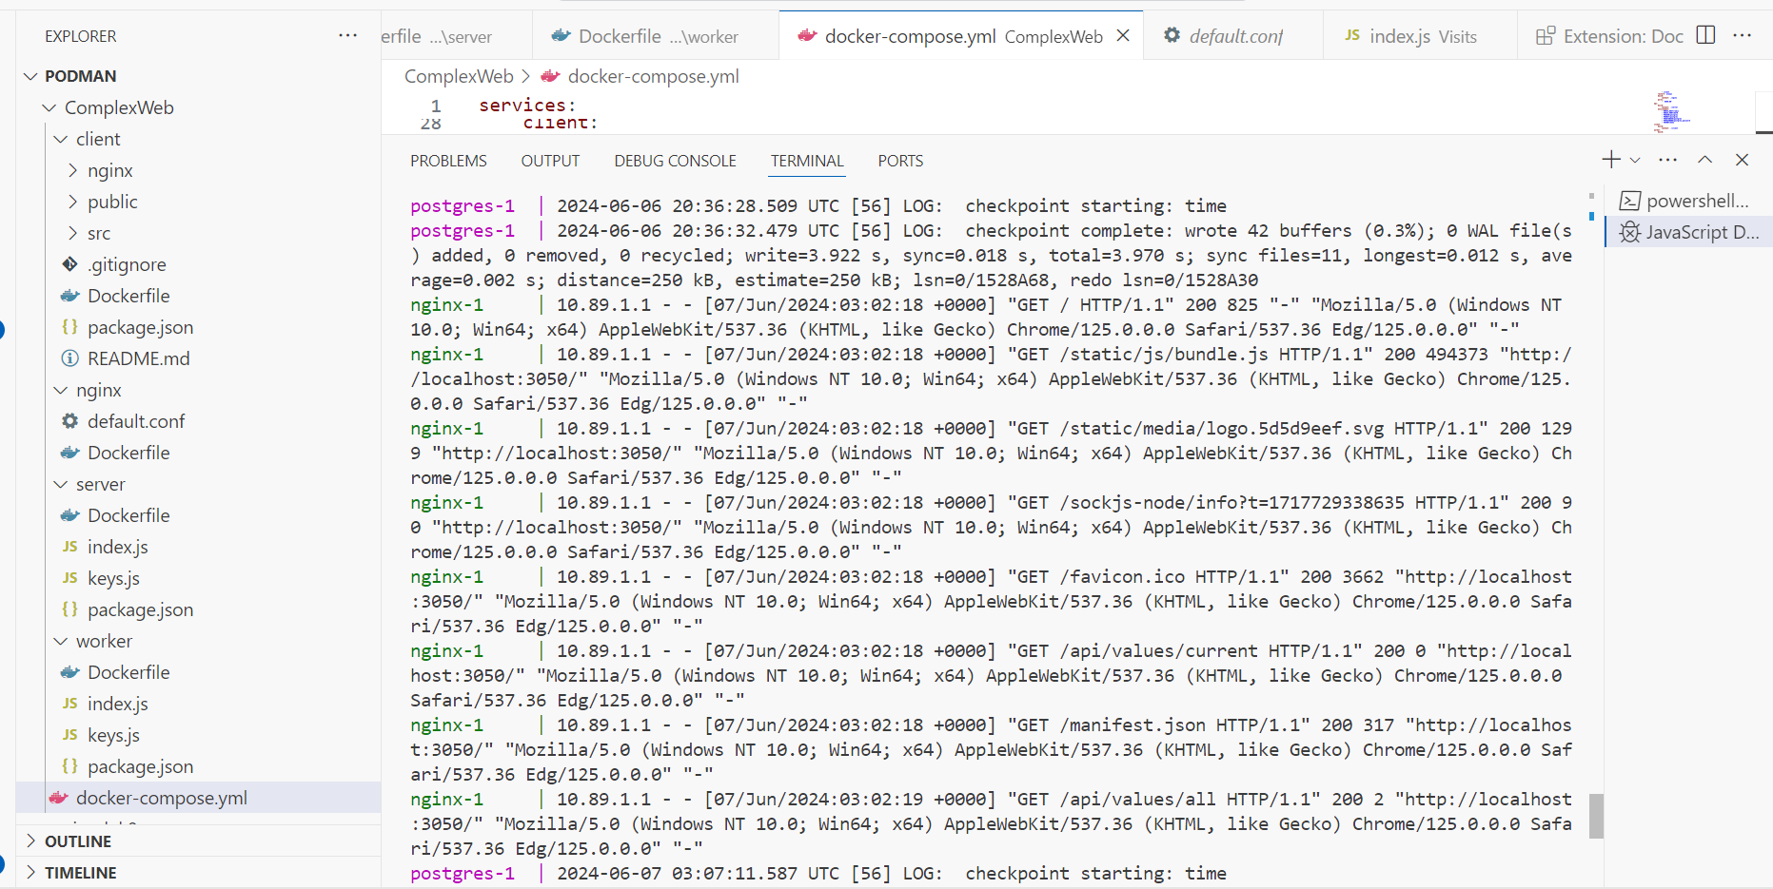

1. Open localhost:3050 in the browser

